How to Use A Microwave To Warm Food
Name
Institution
Date

How to Use a Microwave to Warm Food
The study targets mostly rural areas residents without knowledge on the use of microwave in the homes. It is because most rural residents are illiterate on the usage of modern home appliances. For instance, most would use plastic to warm food hence posing health hazards to themselves. One time plastic materials should not be used to heat food in a microwave as they may damage the microwave itself. The purpose of the paper is to inform the audience on proper way of using microwave.
To accomplish the goals and objectives, you will need
Microwave gadgets
Source of power
Food sample i.e. Rice
Connecting wires
Steps for heating food in a microwave
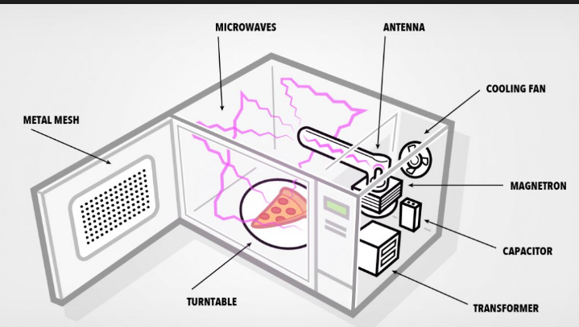
Step 1
Set the microwave in a secure environment where it cannot fall and within easy reach of the source of power.
Source https://www.google.com/search?q=How+to+use+a+microwave+to+warm+food&source=lnms&tbm=isch&sa=X&ved=0ahUKEwies5LfuY3ZAhUMuBQKHWk_Cp4Q_AUICygC&biw=1366&bih=700#imgrc=axqPA-ZOgYqC3M:

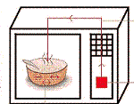
Step 2
Open the microwave door and place food inside the heating area and close the door.
Source
https://www.google.com/search?q=How+to+use+a+microwave+to+warm+food&source=lnms&tbm=isch&sa=X&ved=0ahUKEwies5LfuY3ZAhUMuBQKHWk_Cp4Q_AUICygC&biw=1366&bih=700#imgrc=M9sKoQyaU-9nDM:
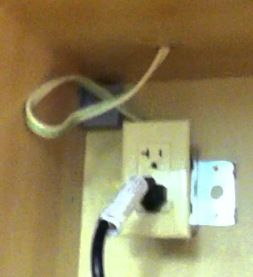
Step 3 connect to source of power
Connect the microwave to the socket to a source of power. The power source should be near the microwave to avoid pulling the cable which may result to heating malfunctions of the microwave.

Source
https://www.google.com/search?biw=1366&bih=700&tbm=isch&sa=1&ei=uqd3WpTIJMyKgAbg1IioAw&q=connect+microwave+topower&oq=connect+microwave+topower&gs_l=psy-ab.3...9979.12593.0.12941.9.9.0.0.0.0.242.1157.2-5.5.0....0...1.1.64.psy-ab..4.2.475...0.0.VhmGUJJ1ncY#imgrc=vmh-ctmLHksG2M:
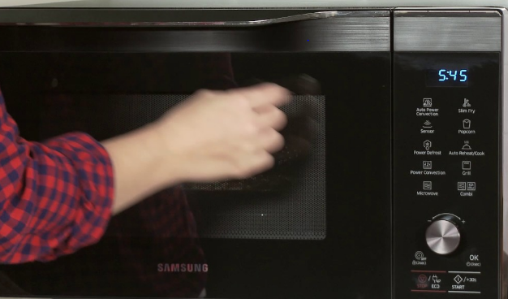
Step 4 Turn on the microwave
Once you connect the microwave to the source of power. There is the need to turn on the microwave to determine its readiness to warm food.
Source
https://www.google.com/search?biw=1366&bih=700&tbm=isch&sa=1&ei=IqV3WofvCeyCgAaagreQBw&q=power+on+the+mocrowave&oq=power+on+the+mocrowave&gs_l=psy-ab.3...979135.983908.0.987612.22.20.0.0.0.0.300.2858.2-11j1.12.0....0...1.1.64.psy-ab..10.7.1748...0j0i67k1j0i8i30k1j0i24k1.0.9r5O9EekJUU#imgrc=_
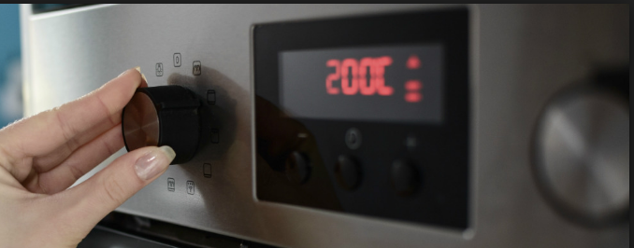
Step 5
Adjust the temperatures to desired levels. It is because different foods heat at varied temperatures.
Source
https://www.google.com/search?biw=1366&bih=700&tbm=isch&sa=1&ei=CKB3Wv2iONjwgAb26KfICg&q=adjusting+microwave+temperatures+and+time&oq=adjusting+microwave+temperatures+and+time&gs_l=psy-ab.3...912671.931005.0.932407.55.48.4.0.0.0.532.7598.2-20j3j3j1.27.0....0...1.1.64.psy-ab..24.14.3635.0..0j0i67k1j0i24k1.0.RNKzD7u6NDk#imgrc=DWkoaf_oZMO_KM:
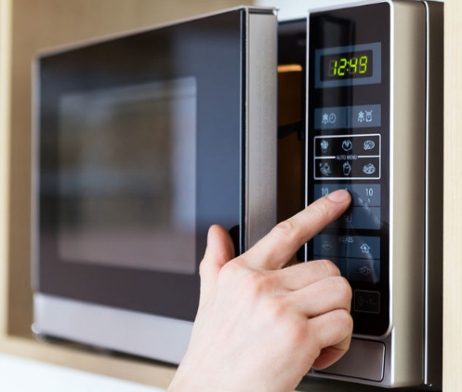
Step 6
Set the expected timelines for heating the food. Different food types usually take different times to warm as opposed to others (Venkatesh, & Raghavan, 2004).

Source
https://www.google.com/search?biw=1366&bih=700&tbm=isch&sa=1&ei=sKN3WsvaCeXSgAb525AQ&q=adjusting+microwave++time&oq=adjusting+microwave++time&gs_l=psy-ab.3..0i24k1.366106.366106.0.367171.1.1.0.0.0.0.246.246.2-1.1.0....0...1.1.64.psy-ab..0.1.244....0.1fH3ENME3QU#imgrc=FOhZCr8u93kEtM:
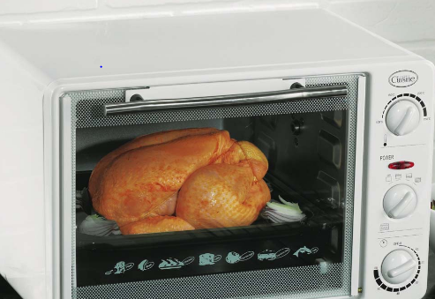
Step 7
Click the start button on the microwave and wait until the time set elapses. The food is now ready to be removed from the microwave.
Source https://www.google.com/search?biw=1366&bih=700&tbm=isch&sa=1&ei=Zqp3WrrOBMviU6jRn_AB&q=heating+food+in+a+microwave&oq=heating+food+in+a+microwave&gs_l=psy-ab.3..0i24k1.16190.25051.0.25826.33.29.2.0.0.0.711.4682.2-12j4j6-1.17.0....0...1.1.64.psy-ab..14.16.4238...0j0i67k1j0i10i67k1j0i5i30k1j0i30k1.0.jtyd6731rZo#imgrc=ZJDHXMEeZbcGZM:
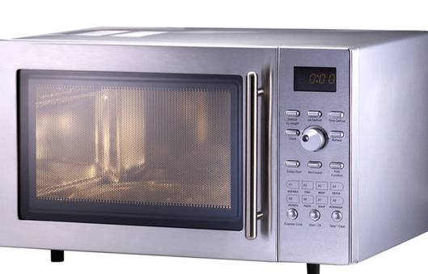
Step 8
Switch off the microwave. This prevents an individual from electric shocks they remove food form the microwave (Vadivambal, & Jayas, 2010).

Source
https://www.google.com/search?biw=1366&bih=700&tbm=isch&sa=1&ei=36t3WqKWH8r_UOfhnaAN&q=Switch+off+the+microwave&oq=Switch+off+the+microwave&gs_l=psy-ab.3...93933.93933.0.95016.1.1.0.0.0.0.205.205.2-1.1.0....0...1.1.64.psy-ab..0.0.0....0.Hn19uQV5oa4#imgrc=UtHx8AC15utEfM:
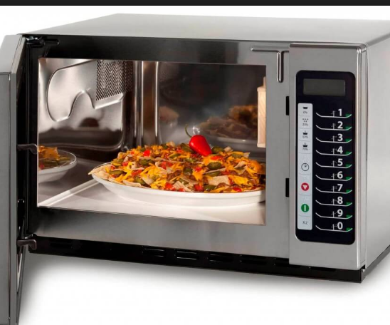

Step 9
Open microwave door and remove the food sample from the microwave

Source
https://www.google.com/search?q=open+microwave+door+and+remove+the+food+sample+from+the+microwave&source=lnms&tbm=isch&sa=X&ved=0ahUKEwjF14LRyI3ZAhWGPRQKHUP4BZIQ_AUICygC&biw=1366&bih=700#imgrc=pos7sue4cH8L_M:
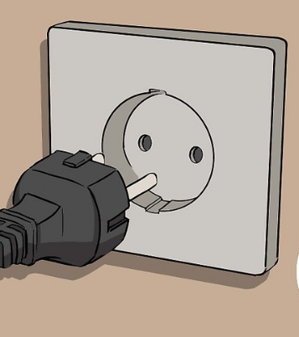
Step 10
Ensure the microwave door is closed and disconnect the power socket from the main power supply. Such prevents the microwave from damage (Leadbeater, 2010).
Source
https://www.google.com/search?biw=1366&bih=700&tbm=isch&sa=1&ei=36t3WqKWH8r_UOfhnaAN&q=Ensure+the+microwave+door+is+closed+and+switch+off+the+power+from+the+main+socket.&oq=Ensure+the+microwave+door+is+closed+and+switch+off+the+power+from+the+main+socket.&gs_l=psy-ab.3...261555.261555.0.262110.1.1.0.0.0.0.206.206.2-1.1.0....0...1.1.64.psy-ab..0.0.0....0.PEaHGzJ6lJc#imgrc=w1D-JqoA7Zx76M:
Conclusion
The procedures are very important for a resident in rural areas. They assist in safe use of microwave hence prevent it from damage. They also aid in prevention of overheating of food due to very high temperatures and exceeded duration. Urban dwellers find it easy to use due to frequent interactions with the microwaves.

References
Leadbeater, N. E. (Ed.). (2010). Microwave heating as a tool for sustainable chemistry. CRC Press.
Vadivambal, R., & Jayas, D. S. (2010). Non-uniform temperature distribution during microwave heating of food materials—A review. Food and Bioprocess Technology, 3(2), 161-171.
Venkatesh, M. S., & Raghavan, G. S. V. (2004). An overview of microwave processing and dielectric properties of agri-food materials. Biosystems Engineering, 88(1), 1-18.

